COMP9414 Artificial Intelligence 18s1

Assignment 2 – Heuristics and Search

WANZE LIU Z5137189

School of Computer Science and Engineering

University of New South Wales

Q1:

Q1:

|  |  |  |  |  |  |
| --- | --- | --- | --- | --- | --- |
| Algroithm | Start10 | Start12 | Start20 | Start30 | Start40 |
| UCS | N = 2565 | Mem | Mem | Mem | Mem |
| IDS | N = 2407 | N = 13812 | N = 5297410 | Time | Time |
| A* | N = 33 | N = 26 | N = 915 | Mem | Mem |
| IDA* | N = 29 | N =21 | N = 952 | N =17297 | N = 112571 |

The Uniform Cost Search has the lowest memorial efficient in these four algorithms, and also the total number of states is the biggest at start10.

The Iterative Deepening Search also generate a large quantity of states ,but it need less space than UCS and time consuming.

The A*Search run extremely fast , but it still needs more space when input arguments becoming bigger.

The Iterative Deepening A*Search needs less space than the third algorithm and its running speed is as fast as the third one , as a result, the last one is the best performance of four algorithm.

Q2:

|  |  |  |  |  |  |  |
| --- | --- | --- | --- | --- | --- | --- |
|  | Start50 | | Start60 | | Start64 | |
| IDA* | 50 | 14642512 | 60 | 321252368 | 64 | 1209086782 |
| 1.2 | 52 | 191438 | 62 | 230861 | 66 | 431033 |
| 1.4 | 66 | 116342 | 82 | 4432 | 94 | 190278 |
| 1.6 | 100 | 33504 | 148 | 55626 | 162 | 235848 |
| Greedy | 164 | 5447 | 166 | 1617 | 184 | 2147 |

The modified part of code show as blow(underline) (an instance of 1.6 and same as others except different coefficients)

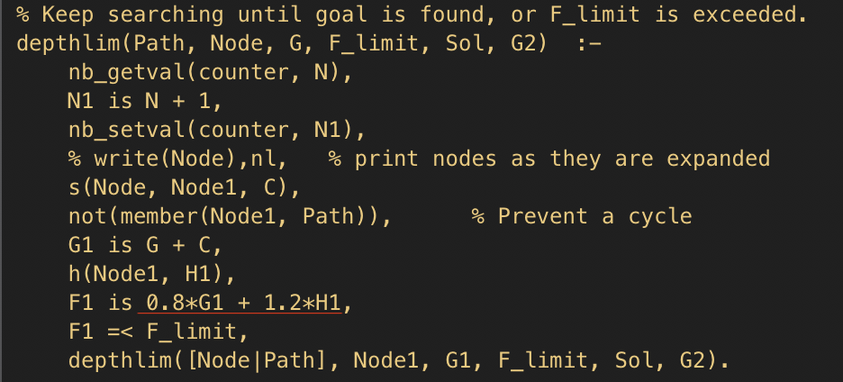

Note: I changed the code of predicate by applying the objective function f(n) = (2-ω)g(n) + ωh(n), the original one is F1 is G1 + H1

Tradeoff:

As the statistics show above, as ω grows from 1 to 2 , the search program speedup a lot, but also the path become larger. hence ,It is possible that it may lead to inaccurate solutions when we apply greater ω.

Q3:

(a)The Manhattan distance is an admissible heuristic that can dominate the Straight -Line-Distance heuristic and it can be describe as following way:

ℎ(𝑥, 𝑦, 𝑥𝐺, 𝑦𝐺 ) = |𝑥 − 𝑥𝐺 | + |𝑦 − 𝑦𝐺 |

(b) i :The Straight -Line-Distance is not admissible in this circumstance ,in this case , no matter it move up ,down ,left ,right or diagonally ,we consider the agent having the ‘same’ cost, while the actual cost is not always equal to the calculate one, as picture show blow, when agent moves from one grid square to another, the actual cost is √2 ,but we just calculate it as 1 , hence, the consequence of this algorithm is smaller than the actual cost, so SLD is not admissible for this case.

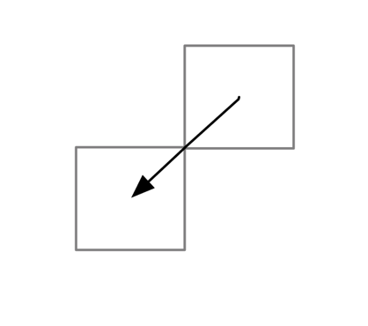

(b) ii: The Manhattan distance is also not admissible in this circumstance, as long as we assume that we have the ‘same ’ cost when we travel diagonally, horizontally and vertically, the actual cost is not same as calculate one ,except only moves horizontally and vertically for this strategies.

(b)iii: In this case ,we can divide it into two parts ,the first part is to calculate the agent moves horizontally and vertically ,and the second is to calculate the agent moves diagonally.

ℎ(𝑥, 𝑦, $x_{G}{, y}_{G}$) = $\left\{\begin{aligned}\left|x - x_{G} \right| if |x - x_{G} | > |y - y_{G} | \\ |y - y_{G} | if |x - x_{G} |≤ |y - y_{G} |\end{aligned}\right.$

Q4:

1. When k = 0 the following is the output of M(n,0) for 1 ≤ n ≤ 21 :

|  |  |  |  |  |  |  |  |  |
| --- | --- | --- | --- | --- | --- | --- | --- | --- |
| n | Optimal sequence | + | - | o | M(n,0) | Time steps | 2s+1 | 2s+2 |
| 0 |  | 0 | 0 | 0 | 0 | 0 | 1 | 2 |
| 1 | + - | 1 | 1 | 0 | 2 | 2 | 3 | 4 |
| 2 | + o - | 1 | 1 | 1 | 3 | 3 | 3 | 4 |
| 3 | + o o - | 1 | 1 | 2 | 4 | 4 | 5 | 4 |
| 4 | + + - - | 2 | 2 | 0 | 4 | 4 | 5 | 6 |
| 5 | + + - o - | 2 | 2 | 1 | 5 | 5 | 5 | 6 |
| 6 | + + o - - | 2 | 2 | 1 | 5 | 5 | 5 | 6 |
| 7 | + + o - o - | 2 | 2 | 2 | 6 | 6 | 5 | 6 |
| 8 | + + o o - - | 2 | 2 | 2 | 6 | 6 | 5 | 6 |
| 9 | + + + - - - | 3 | 3 | 0 | 6 | 6 | 7 | 8 |
| 10 | + + + - - o - | 3 | 3 | 1 | 7 | 7 | 7 | 8 |
| 11 | + + + - o - - | 3 | 3 | 1 | 7 | 7 | 7 | 8 |
| 12 | + + + o - - - | 3 | 3 | 1 | 7 | 7 | 7 | 8 |
| 13 | + + + o - - o - | 3 | 3 | 2 | 8 | 8 | 7 | 8 |
| 14 | + + + o - o - - | 3 | 3 | 2 | 8 | 8 | 7 | 8 |
| 15 | + + + o o - - - | 3 | 3 | 2 | 8 | 8 | 8 | 8 |
| 16 | + + + + - - - - | 4 | 4 | 0 | 8 | 8 | 9 | 10 |
| 17 | + + + + - - - o - | 4 | 4 | 1 | 9 | 9 | 9 | 10 |
| 18 | + + + + - - o - - | 4 | 4 | 1 | 9 | 9 | 9 | 10 |
| 19 | + + + + - o - - - | 4 | 4 | 1 | 9 | 9 | 9 | 10 |
| 20 | + + + + o - - - - | 4 | 4 | 1 | 9 | 9 | 9 | 10 |
| 21 | + + + + o - - - o - | 4 | 4 | 2 | 10 | 10 | 9 | 10 |

(b)As table show above ,the time steps is the length of the minimum number of time steps and we also can obtain the same results by applying the following formula

$M(n,0) = \left\lceil 2\sqrt{n}\right\rceil$ (1)

if we assume the following identity, the s represents the maximum speed(eg. ++o-o- ,the maximum speed is 2,because there are two ‘+’), and 2s + 1 for there is one rest (rg. ++o--)and 2s + 2 for there are two rests(eg. ++o-o-).

However , when n is 4,9 or 16 ,n is not satisfied with this identity, because there are no rests.

$\left\lceil 2\sqrt{n}\right\rceil$*= $\left\{\begin{aligned}2s+1 if s^{2}<n s(s+1) \\ 2s+2 if s(s+1)<n {(s+1)}^{2}\end{aligned}\right.$* (2)

(c)According to the question ,we assume that k > 0 which means we are starting at S with speed K, and if n ≥ k(k-1) then we stop at or before G, therefor we assume the deceleration time of M(n,0) for total distance x could be minusing the time that accelerate to k which is:

*M(n,0) = $\left\lceil 2\sqrt{x}\right\rceil$- k* (3)

From Gaussian summation formula we can now the time that accelerate to k is:

$\frac{k(k+1)}{2}$ (4)

And when we start at speed of k which means the total distance is x = n + $\frac{k(k+1)}{2}$, so substituting this into (3):

*M(n,k) = $\left\lceil 2\sqrt{n+\frac{k(k+1)}{2} }\right\rceil$- k* (5)

(d) k ≥ 0 and n k(k-1) is the opposite circumstance of n ≥ k(k-1) ,so when n k(k-1) we go beyond the goal and need to go back to it ,therefore, the total distance could be total time + back time – acceleration time which is :

*M(n,k) = $\left\lceil 2\sqrt{\frac{k(k-1)}{2}+\frac{k(k+1)}{2} }\right\rceil$*  *+ $\left\lceil 2\sqrt{\frac{k(k-1)}{2}-n}\right\rceil$- k* (6)

simplify it and final result is :

*M(n,k) = $\left\lceil 2\sqrt{\frac{k(k-1)}{2}-n }\right\rceil$ + k* (7)

(e)from 1-dimensional to 2-dimensional for this game we can get:

*h(r,c,u,v,rG,cG)=max(M( $r_{G}$ −r,u),M( $c_{G}$ −c,v))* (8)

where M() is from (5).

The reason for proving its admissibility is that it just considers the maximum difference between two coordinates either 𝑟 or 𝑐,which means that even the agent take diagonal distances, this heuristic is still admissible due to it counts diagonal distances as straight-line and calculate them as normal.